**12. ReactJS HOL Solutions**

**App.js**

import React, { useState } from 'react';

// Greeting Component

function Greeting(props) {

const isLoggedIn = props.isLoggedIn;

if (isLoggedIn) {

return <UserGreeting />;

}

return <GuestGreeting />;

}

// UserGreeting Component

function UserGreeting() {

return (

<div>

<h1>Welcome back</h1>

<p>You can now book your flight tickets.</p>

</div>

);

}

// GuestGreeting Component

function GuestGreeting() {

return (

<div>

<h1>Please sign up.</h1>

<p>Here are the available flight details.</p>

</div>

);

}

// LoginButton Component

function LoginButton(props) {

return <button onClick={props.onClick}>Login</button>;

}

// LogoutButton Component

function LogoutButton(props) {

return <button onClick={props.onClick}>Logout</button>;

}

// App Component

function App() {

const [isLoggedIn, setIsLoggedIn] = useState(false);

const handleLoginClick = () => setIsLoggedIn(true);

const handleLogoutClick = () => setIsLoggedIn(false);

let button;

if (isLoggedIn) {

button = <LogoutButton onClick={handleLogoutClick} />;

} else {

button = <LoginButton onClick={handleLoginClick} />;

}

return (

<div>

<Greeting isLoggedIn={isLoggedIn} />

{button}

</div>

);

}

export default App;

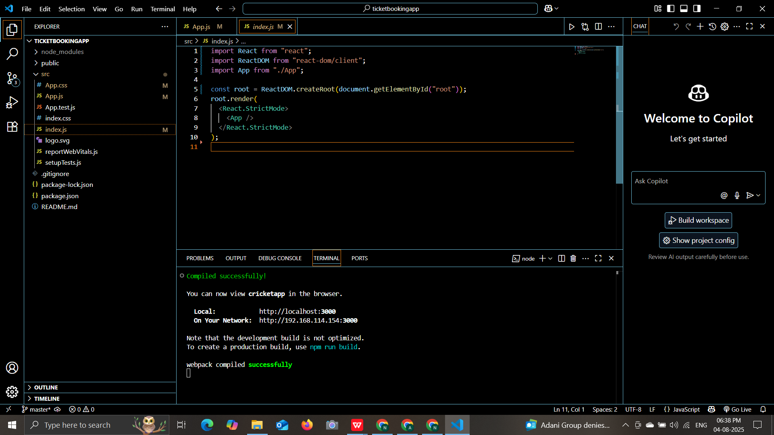

**OUTPUT:**

